**Create a VPC with 120.0.0.0/16 CIDR block**

**A VPC is an isolated portion of the AWS Cloud populated by AWS objects, such as Amazon EC2 instances**.

Name tag 🡪 IPv4 CIDR block 🡪 IPv4 CIDR 🡪 IPv6 CIDR block 🡪 Create VPC

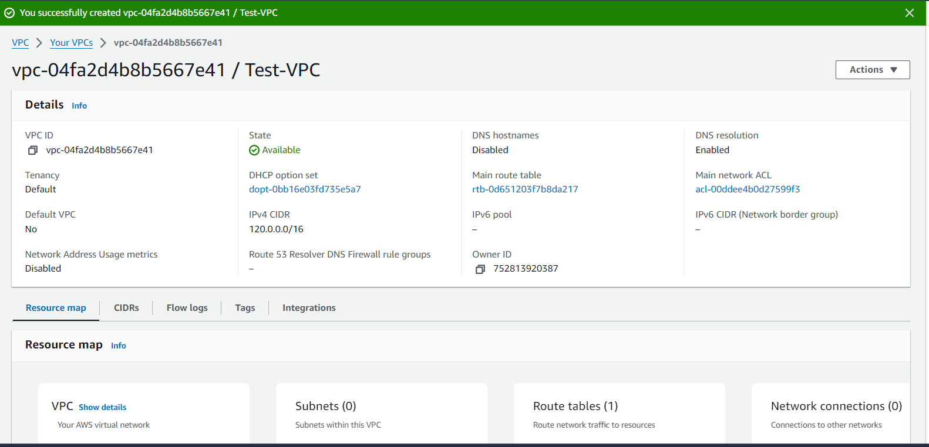

**Create subnet:**

Select here VPC 🡪 Specify the CIDR blocks and Availability Zone for the subnet

🡪 **Subnet 01: IPv**4 subnet CIDR block: 120.0.1.0/24 (Public)

🡪 **Subnet 02: IPv**4 subnet CIDR block: 120.0.2.0/24(Private)

🡪 **Subnet 03: IPv**4 subnet CIDR block: 120.0.3.0/24(Private)

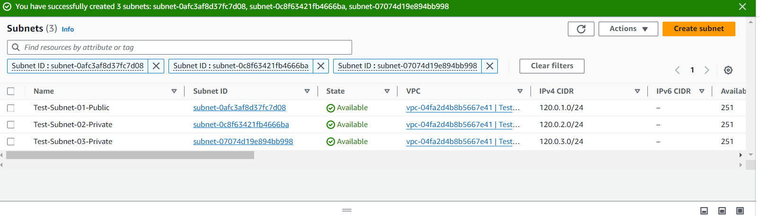

**Create Internet gateway and attach VPC:**

Create Internet Gateway 🡪 attach to VPC

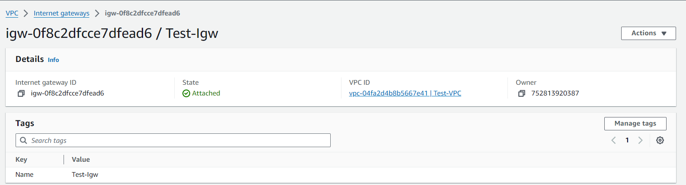

**Create route table:**

**A route table specifies how packets are forwarded between the subnets within your VPC, the internet, and your VPN connection.**

Create route table and attach to VPC

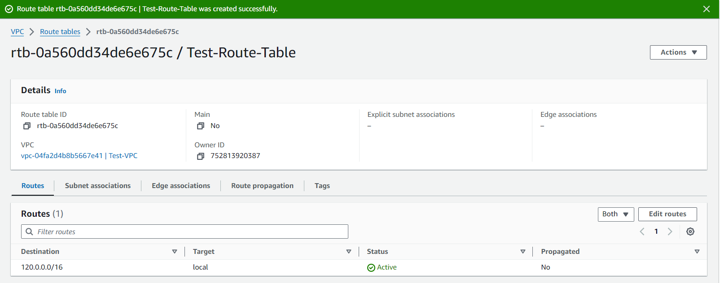

Goto Route-table 🡪 Edit Routes 🡪 add Target and Destination (igw-0.0.0.0/0)

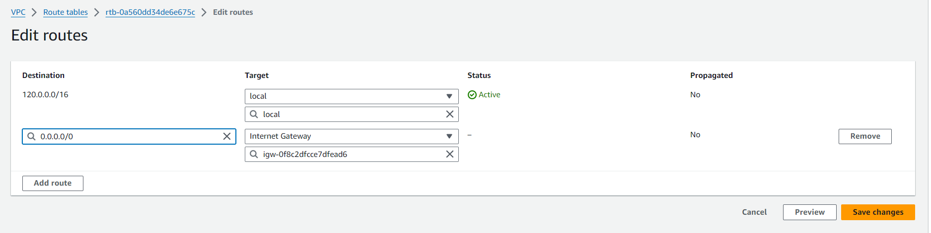

Change Test-Subnet-01-Public is associated with this route table rtb-0a560dd34de6e675c

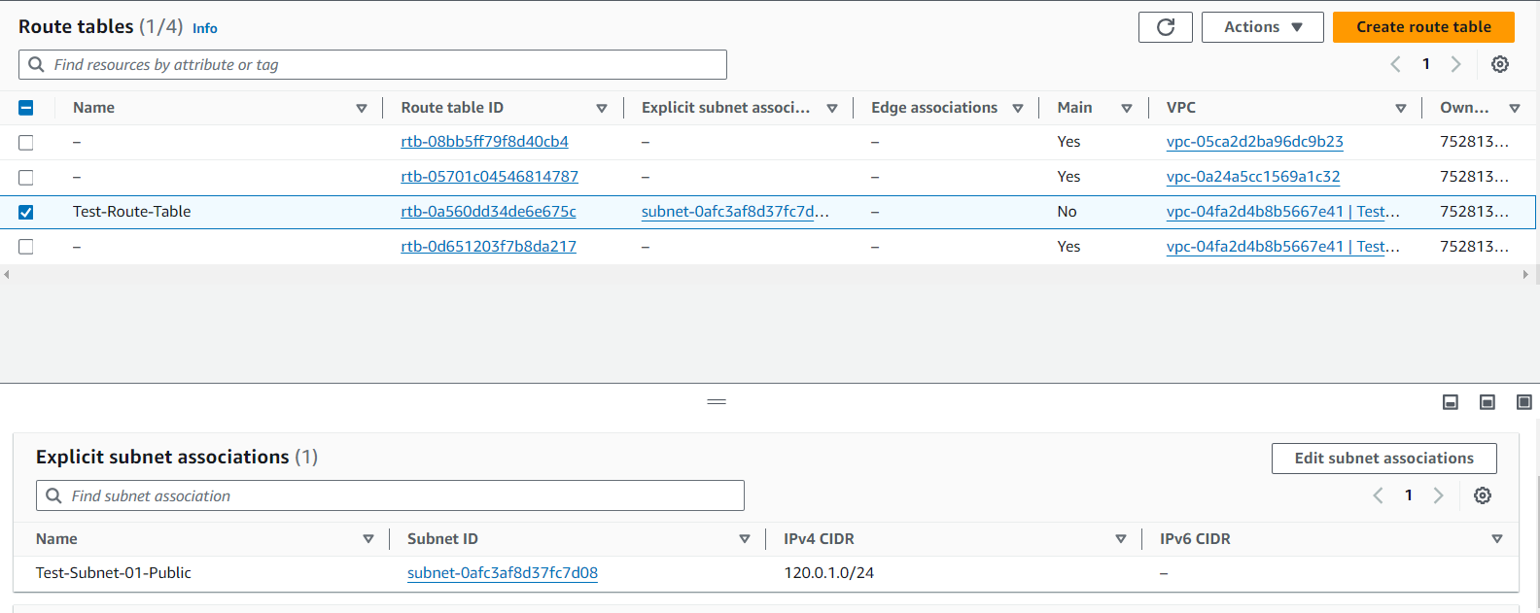

Go to Test-Subnet-01-Public 🡪 Edit Subnet settings 🡪 go to auto – assign IP settings 🡪 Enable AWS to automatically assign a public IPv4 address to a new primary network interface for an instance in this subnet.

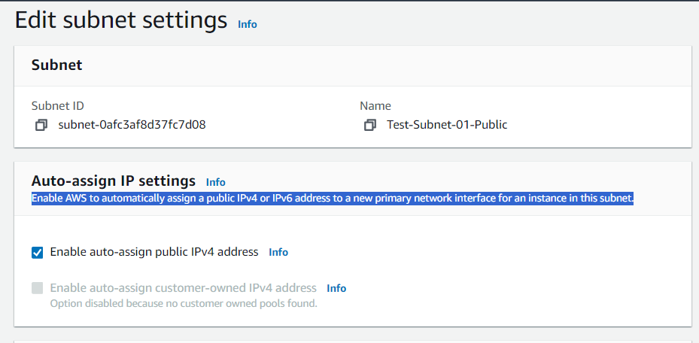

Launch instance 1 (public):

Launch the Instance; Configure with VPC and Public Subnet

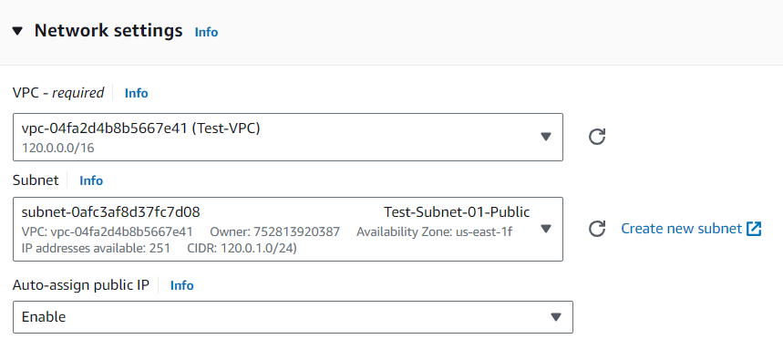

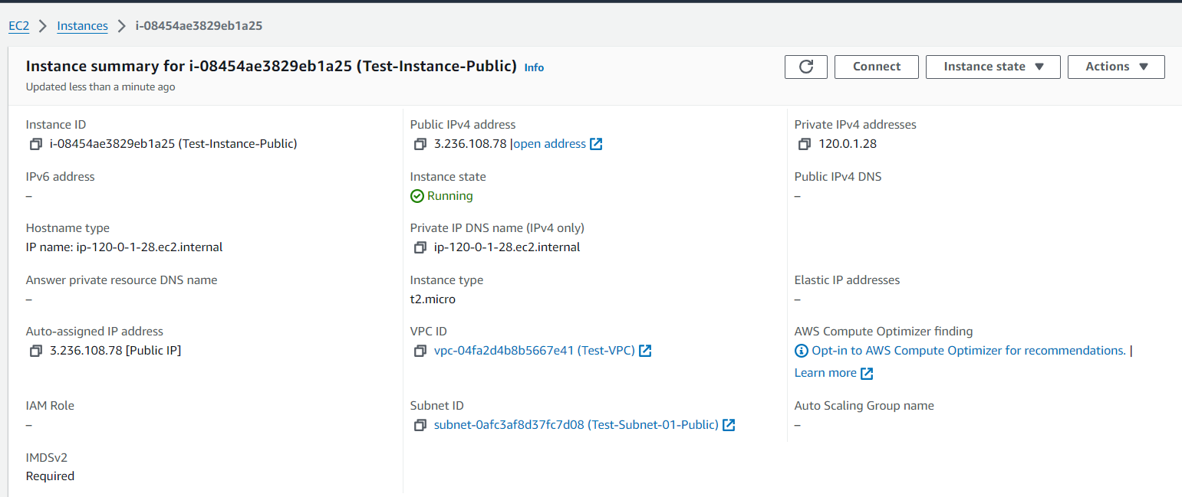

Launch Instance 2 (Private):

Launch the Instance; Configure with VPC and Private Subnet

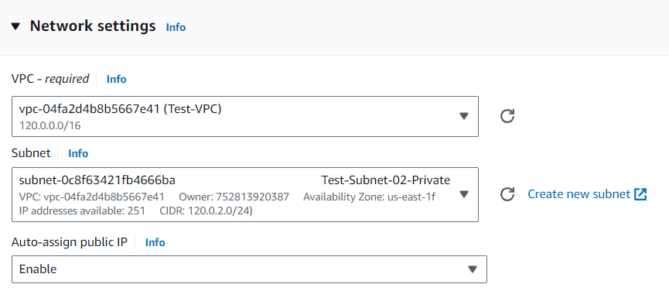

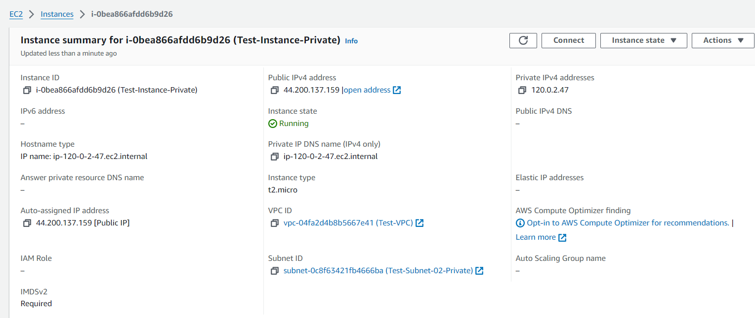

**Create NAT gateway:**

**A highly available, managed Network Address Translation (NAT) service that instances in private subnets can use to connect to services in other VPCs, on-premises networks, or the internet.**

Name 🡪 Select a subnet in which to create the NAT gateway🡪 Select a connectivity type for the NAT gateway 🡪 Assign an Elastic IP address to the NAT gateway (lastic IP address 18.206.113.255 (eipalloc-0b924b316d1388c05) allocated.) 🡪 create NAT gateway

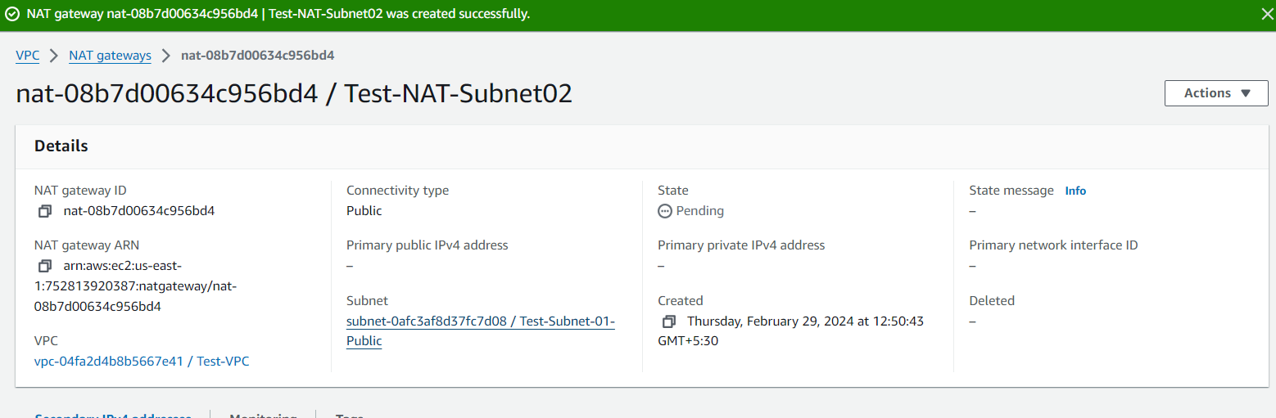

**Commands to connect to private instance:**

🡪 sudo nano test-key.pem (create a keypair in public instance)

🡪ls

🡪sudo chmod 400 “test-key.pem” (change the permission of keypair file)

🡪 sudo ssh -i "test-key.pem" ubuntu@120.0.2.186 (used to ssh into private instance)

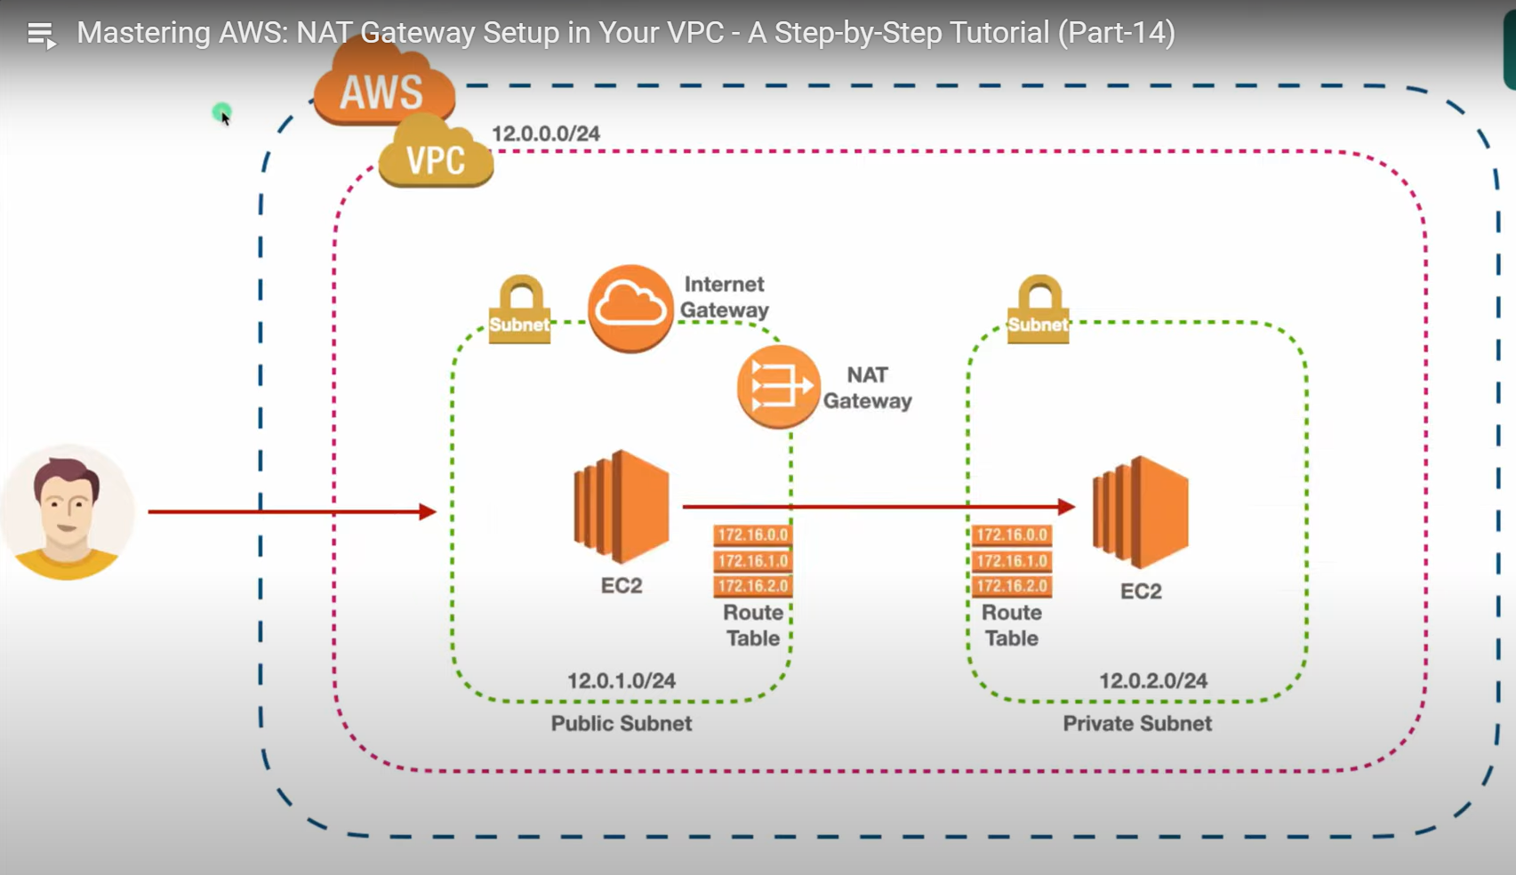

Create 1 vpc, 2subnets,2 route tables,1 igw, 1nat gateway,2 ec2 instances

----************----